CSA1509-Cloud computing and Big Data Analytics
Name : DHARSHANA SIVAKUMAR
Reg.no: 192511054

EXP17- Change Hardware compatibility of a VM (Either by clone/create new one) which is already created and configured and run simple unix commands
Aim:
Change Hardware compatibility of a VM (Either by clone/create new one) which is already created and configured and run simple unix
Steps:
- Download VMware software and install it as Type-2 Hypervisor.
- Download Ubuntu or tiny os as ISO image file.
- In VMware workstation Create new VM
- Do the configuration based on given conditions.
- Create VM
- Go to VM ManageClone.
- A Orange colour desktop will open, simple unix commands are performed.
- Launch the VM.
Implementation:
- Download and open VMware software.
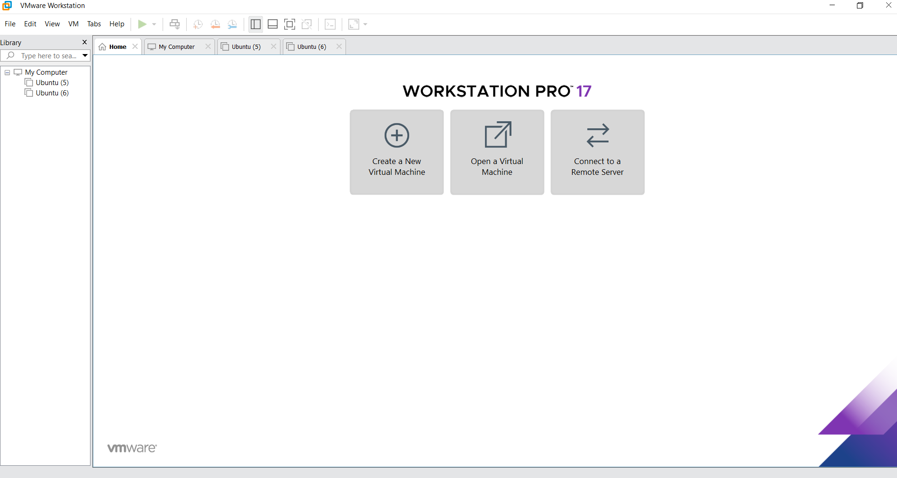
2.Create a new VM

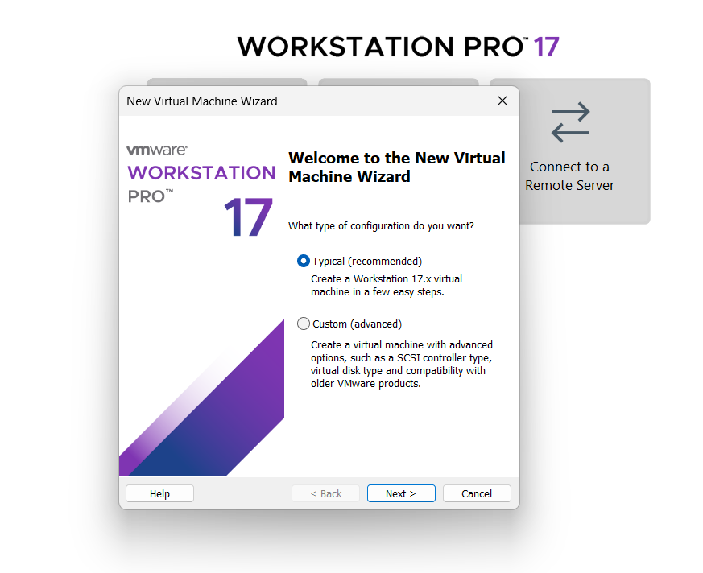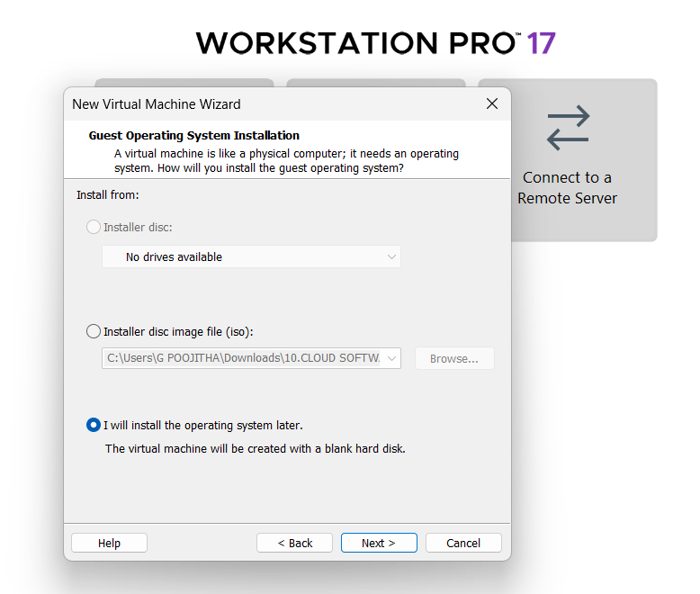
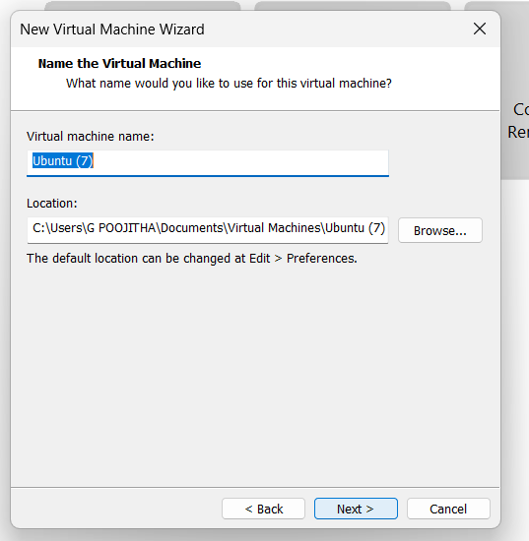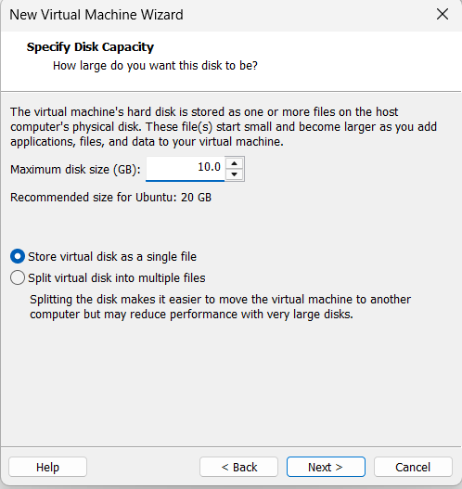
Fig : Name it anythingclick on nextAdjust the size of disk change the option to first and then click on next.
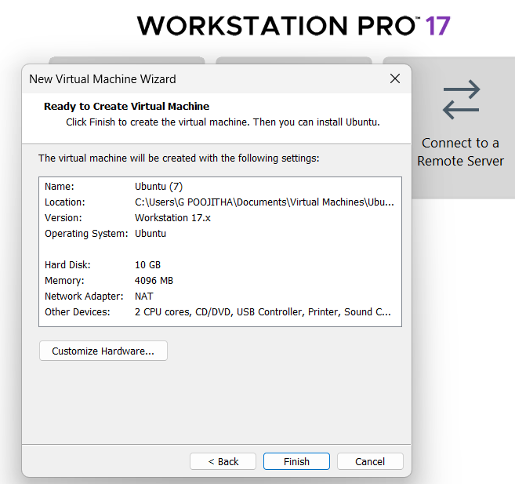Fig: Click on Finish to Launch .
3.VM is created
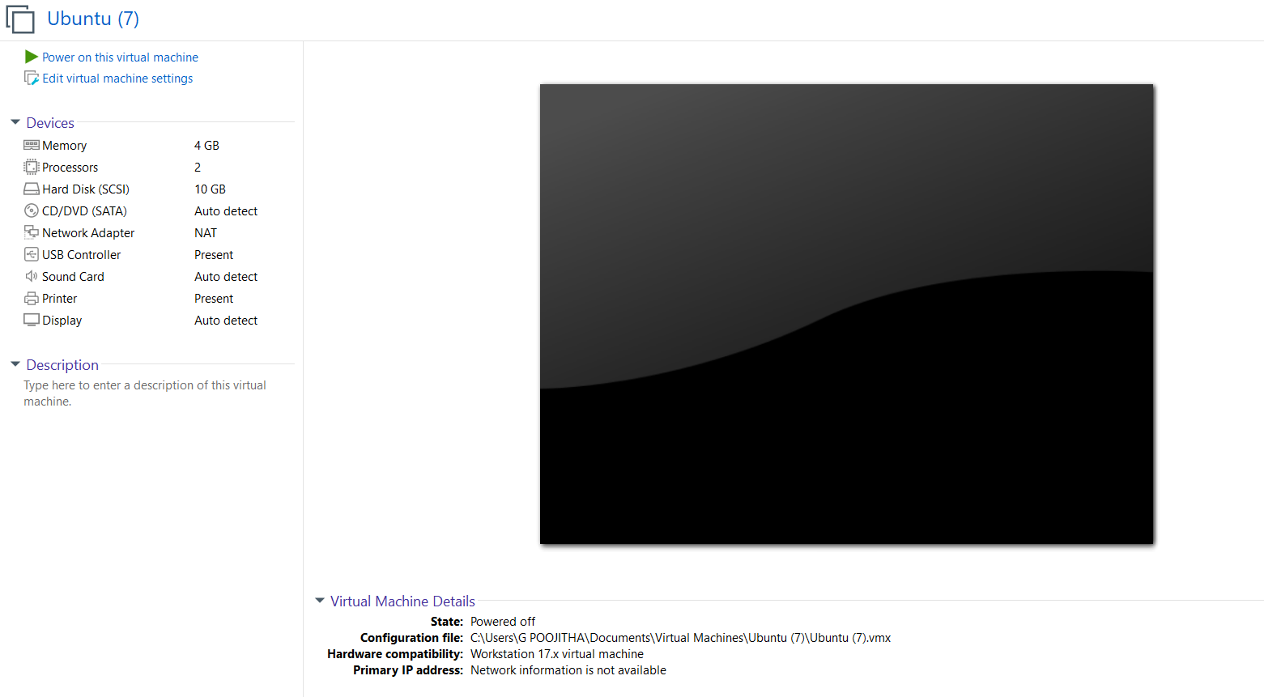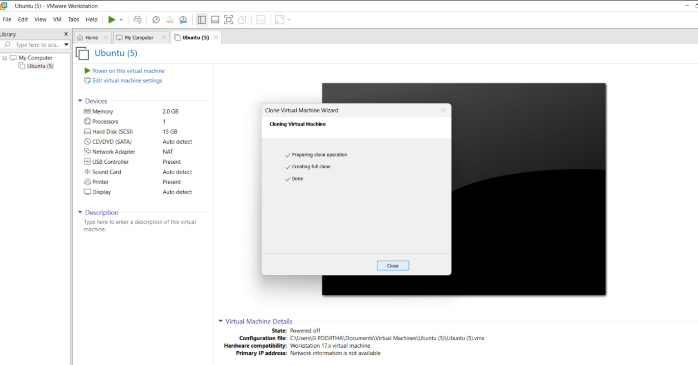
4. Create Clone
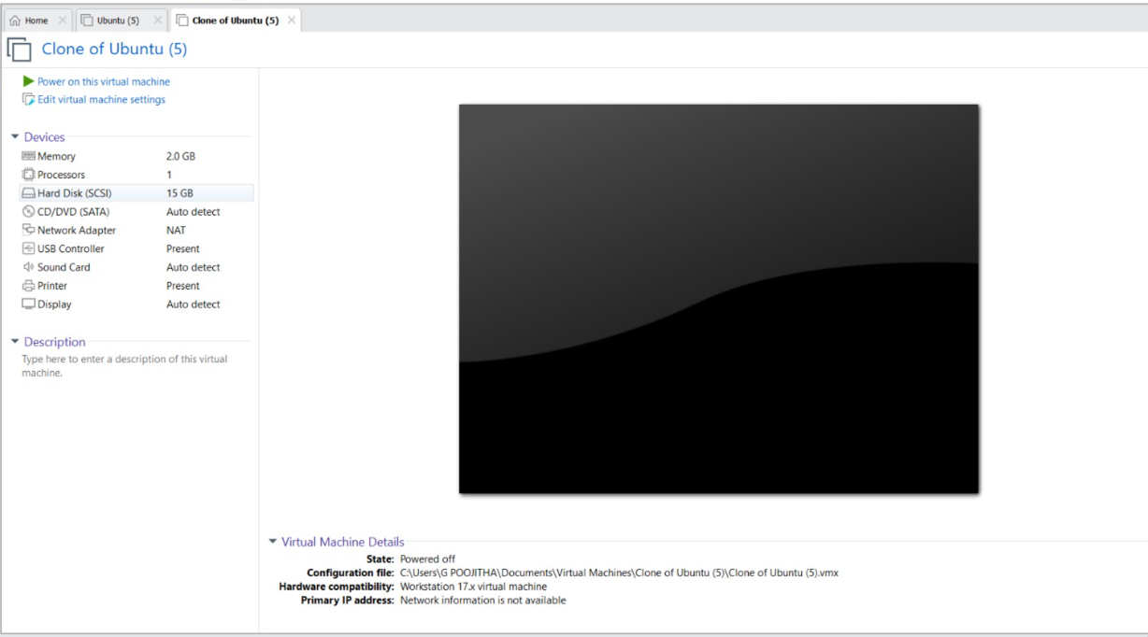
Fig : SSClone has Created and it has same properties as before VM.

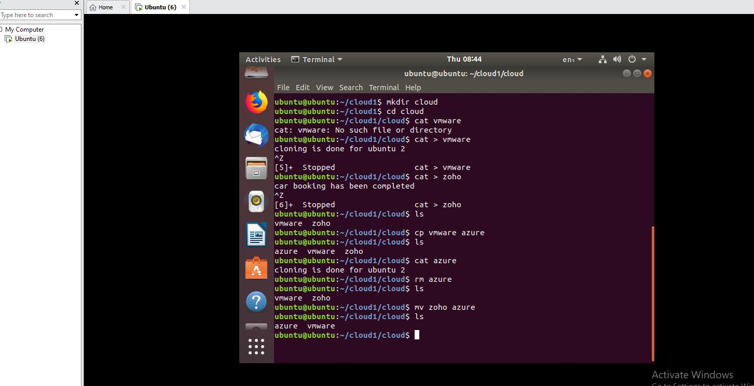
Fig : unix commands are performed

